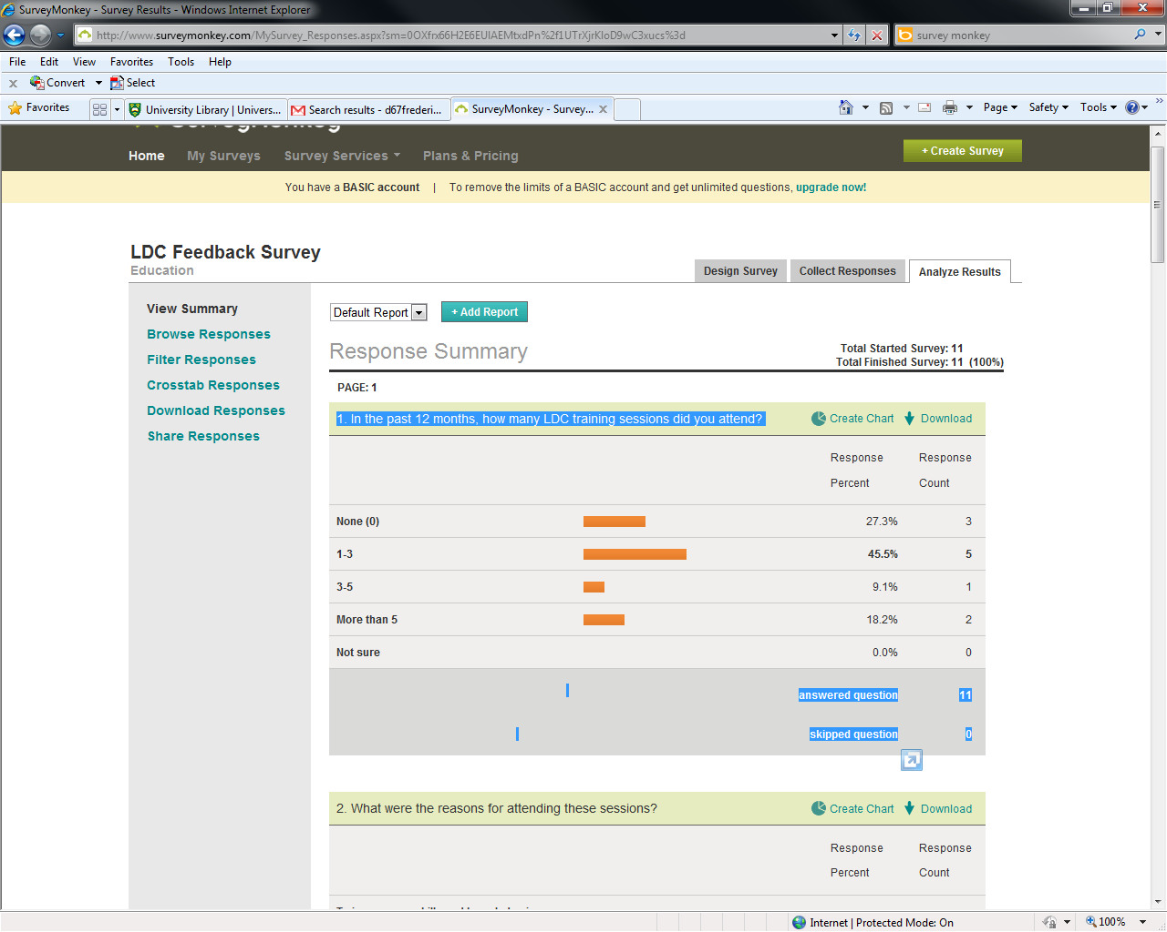

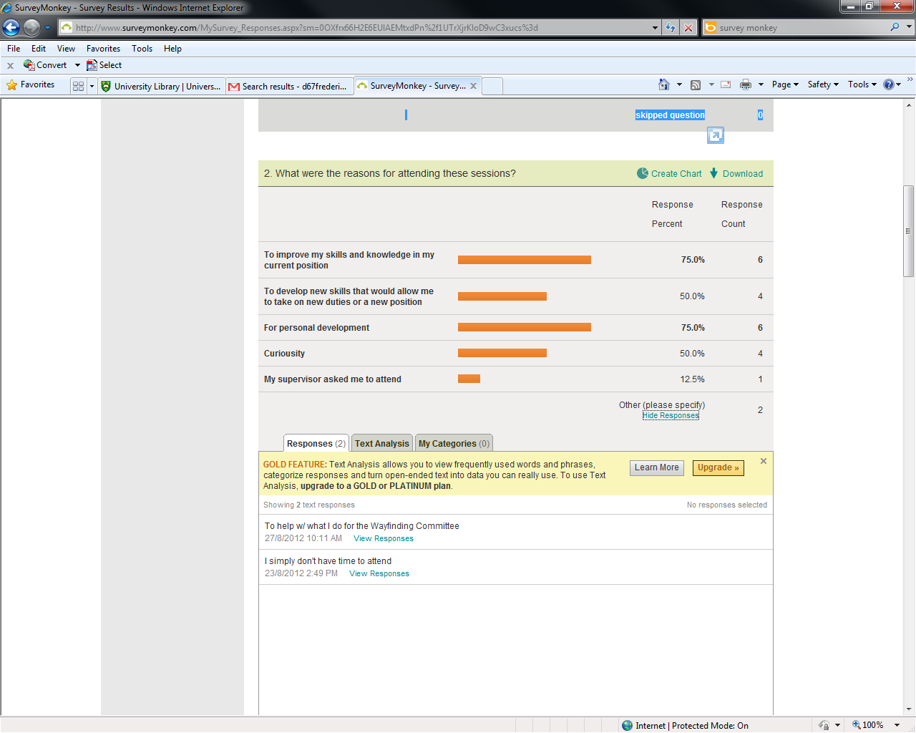

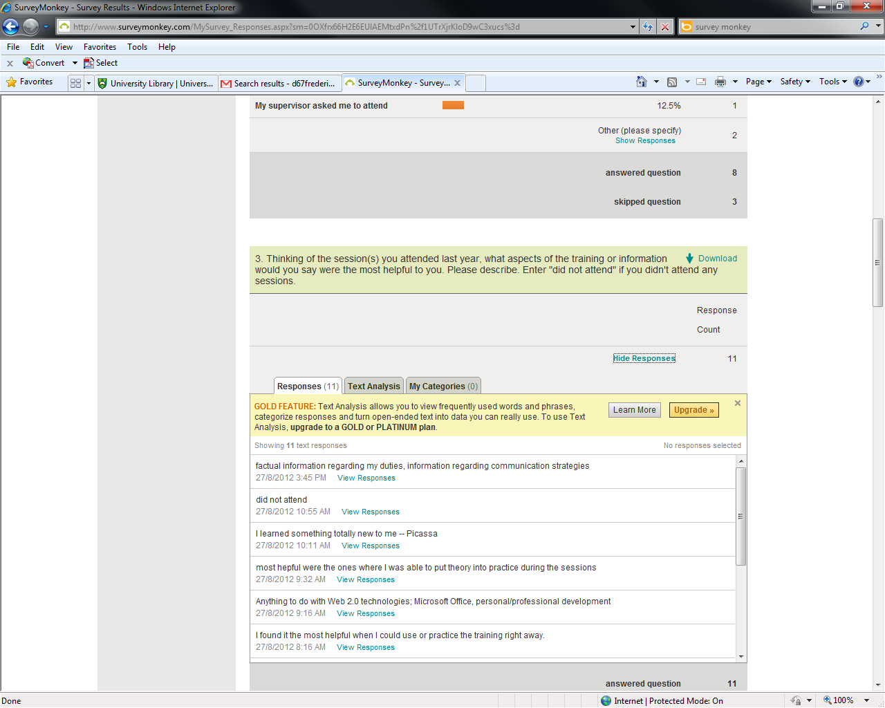

did not attend

23/8/2012 2:49 PM[View Responses](http://www.surveymonkey.com/MySurvey_ResponsesDetail.aspx?sm=0OXfrx66H2E6EUlAEMtxdDZ8h6K4yy5Ki7AdmvhqaHjVmhx1agUrAzWYwsezj5osGl8NkF_2Bn5v4t_0AkQOM0KZLuA_3D_3D_0A)

Interacting with colleagues from different branches of the library and helping each other to learn. I especially enjoyed the Scavenger Hunt for that reason - seeing what is unique or interesting about the other Library work environments.

23/8/2012 1:16 PM[View Responses](http://www.surveymonkey.com/MySurvey_ResponsesDetail.aspx?sm=0OXfrx66H2E6EUlAEMtxdDZ8h6K4yy5Ki7AdmvhqaHgHUDoXgFtgB7hUbFbSifRlgMRjhXCx5be7_0A/KnL/x_2BuJQ_3D_3D_0A)

did not attend

23/8/2012 8:13 AM[View Responses](http://www.surveymonkey.com/MySurvey_ResponsesDetail.aspx?sm=0OXfrx66H2E6EUlAEMtxdDZ8h6K4yy5Ki7AdmvhqaHgHUDoXgFtgB7hUbFbSifRlvMxR66j6gDJn_0AEofI4Dd8NA_3D_3D_0A)

It was not a good session. I can't think of anything helpful from it.

23/8/2012 7:04 AM[View Responses](http://www.surveymonkey.com/MySurvey_ResponsesDetail.aspx?sm=0OXfrx66H2E6EUlAEMtxdDZ8h6K4yy5Ki7AdmvhqaHgHUDoXgFtgB7hUbFbSifRlAm1Ty_2BuLuG2o_0AaWf5XM1xTw_3D_3D_0A)

I liked the sessions that were hands on

22/8/2012 4:51 PM[View Responses](http://www.surveymonkey.com/MySurvey_ResponsesDetail.aspx?sm=0OXfrx66H2E6EUlAEMtxdDZ8h6K4yy5Ki7AdmvhqaHgHUDoXgFtgB7hUbFbSifRlKKxIPu8mxT08_0AEoG1A99i4g_3D_3D_0A)

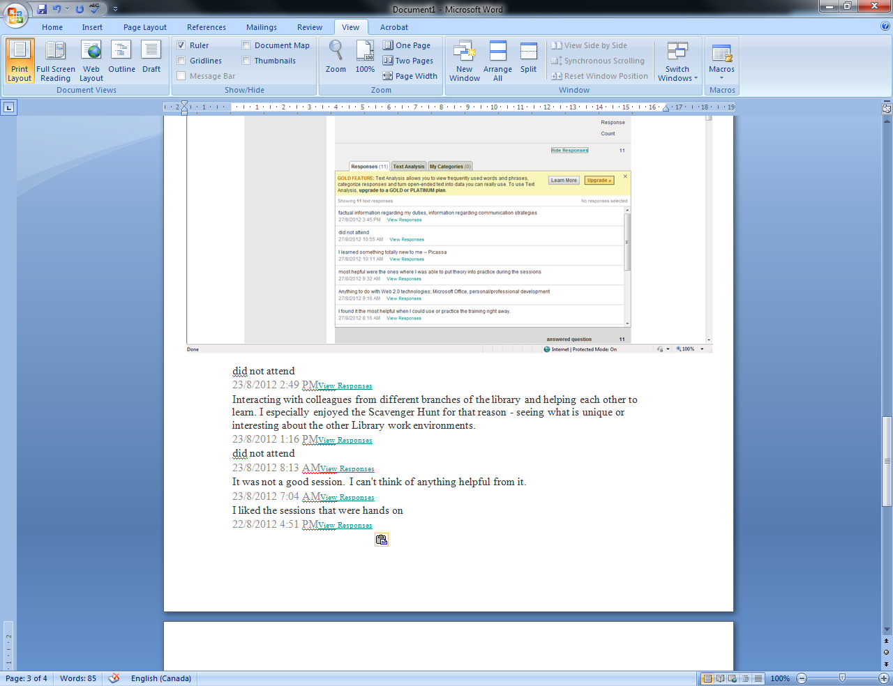

none

23/8/2012 2:49 PM[View Responses](http://www.surveymonkey.com/MySurvey_ResponsesDetail.aspx?sm=0OXfrx66H2E6EUlAEMtxdDZ8h6K4yy5Ki7AdmvhqaHjVmhx1agUrAzWYwsezj5osGl8NkF_2Bn5v4t_0AkQOM0KZLuA_3D_3D_0A)

I really don't enjoy the webinar sessions although they are getting better (or I am getting more used to them!). When the sessions are done by a colleague or other person from the U of S I find it engaging. I tend to be distracted easily during webinars, especially when the quality is poor in volume or their is a lot of background noise.

23/8/2012 1:16 PM[View Responses](http://www.surveymonkey.com/MySurvey_ResponsesDetail.aspx?sm=0OXfrx66H2E6EUlAEMtxdDZ8h6K4yy5Ki7AdmvhqaHgHUDoXgFtgB7hUbFbSifRlgMRjhXCx5be7_0A/KnL/x_2BuJQ_3D_3D_0A)

none

23/8/2012 8:13 AM[View Responses](http://www.surveymonkey.com/MySurvey_ResponsesDetail.aspx?sm=0OXfrx66H2E6EUlAEMtxdDZ8h6K4yy5Ki7AdmvhqaHgHUDoXgFtgB7hUbFbSifRlvMxR66j6gDJn_0AEofI4Dd8NA_3D_3D_0A)

Turned out to be a frustrating session with very little information to take away. The presenters didn't seem to be 'engaged'.

23/8/2012 7:04 AM[View Responses](http://www.surveymonkey.com/MySurvey_ResponsesDetail.aspx?sm=0OXfrx66H2E6EUlAEMtxdDZ8h6K4yy5Ki7AdmvhqaHgHUDoXgFtgB7hUbFbSifRlAm1Ty_2BuLuG2o_0AaWf5XM1xTw_3D_3D_0A)

I don't like just sitting there and listening for a long period of time.

22/8/2012 4:51 PM[View Responses](http://www.surveymonkey.com/MySurvey_ResponsesDetail.aspx?sm=0OXfrx66H2E6EUlAEMtxdDZ8h6K4yy5Ki7AdmvhqaHgHUDoXgFtgB7hUbFbSifRlKKxIPu8mxT08_0AEoG1A99i4g_3D_3D_0A)

